Lab 2

**Ex1**

Question 1: What is the content type of the response? What is the size of the response? When was the webpage last modified? Do you see an "Accept-Ranges" header field? What may this be used for?

(1) The content type is text/html.

(2) The size of the response is 4839.

(3) Its last modification was on Thu, 01 Nov 2018 00:17:53 GMT.

(4) The content in the “Accept-Ranges” is None

(5) The HTTP Accept-Ranges is the Response type header also the part of the ranges system. This header act as a marker that is used by the server to supports the partial request of the clients.

Question 2: What is the content type of the response? What is the size of the response?

(1) the type is text/html

Question 3: Using telnet, find a way to get the people.html webpage from vision.ucla.edu

telnet vision.ucla.edu 80

GET /people.html HTTP/1.1

host: [www.vision.ucla.edu](http://www.vision.ucla.edu)

Question 4: Why is there the need to include the host in the GET (and HEAD) HTTP 1.1 request messages?

The [Host](https://tools.ietf.org/html/rfc7230#section-5.4) HTTP header is mandatory since HTTP/1.1 and it's used for virtual hosting. It must include the domain name of the server, and the TCP port number on which the server is listening. The port number may be omitted if the port is the standard port for the service requested (80 for HTTP and 443 for HTTPS).

**Exercise 3: Using Wireshark to understand basic HTTP request/response messages**

**Question 1: What is the status code and phrase returned from the server to the client browser?**

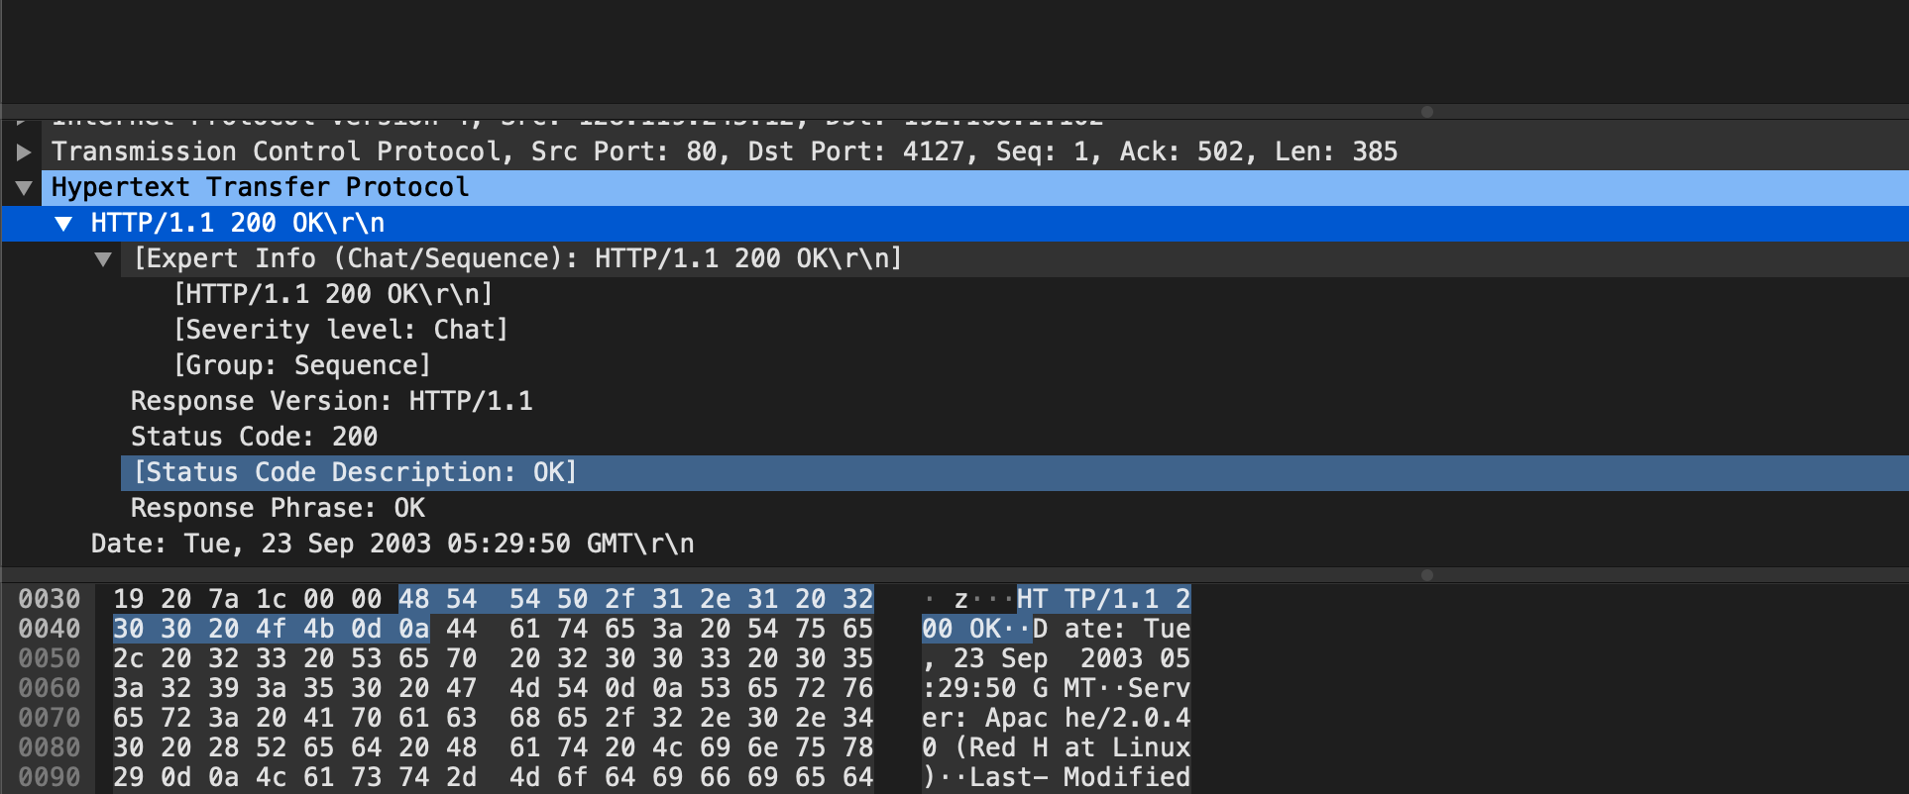

Here are the status code and the phrase. 200 OK

**Question 2: When was the HTML file that the browser is retrieving last modified at the server? Does the response also contain a DATE header? How are these two fields different?**

(1) Using the command http.last_modified to filter out the detail of last modification. Its last modification occurred in Tue, 23 Sep 2003 05:29:00

(2) It also contains a DATE header. In general, these two field is almost the same. Except the seconds of time displayed, where the Date header (05:29:50) is slightly later than Last-Modified (05:29:00), other details are the same.

**Question 3: Is the connection established between the browser and the server persistent or non-persistent? How can you infer this?**

As the screen shot shows, the connection keeps alive, which is persistent. Actually, this is also a default option of HTTP/1.1.

**Question 4: How many bytes of content are being returned to the browser?**

73 bytes are being returned

**Question 5: What is the data contained inside the HTTP response packet?**

**Exercise 4: Using Wireshark to understand the HTTP CONDITIONAL GET/response interaction**

**Question 1: Inspect the contents of the ﬁrst HTTP GET request from the browser to the server. Do you see an “IF-MODIFIED-SINCE” line in the HTTP GET?**

NO

**Question 2:** **Does the response indicate the last time that the requested ﬁle was modiﬁed?**

Yes

**Question 3: Now inspect the contents of the second HTTP GET request from the browser to the server. Do you see an “IF-MODIFIED-SINCE:” and “IF-NONE-MATCH” lines in the HTTP GET? If so, what information is contained in these header lines?**

If-Modified-Since: Tue, 23 Sep 2003 05:35:00 GMT\r\n

If-None-Match: "1bfef-173-8f4ae900"\r\n

**Question 4: What is the HTTP status code and phrase returned from the server in response to this second HTTP GET? Did the server explicitly return the contents of the ﬁle? Explain.**

(1) The status code and phrase: 304 Not Modified

(2) The server did not return all of details of the file as it just display contents from buffer. And the file was modified before, which means that it has been accessed. That would return content of the file.

**Question 5: What is the value of the Etag ﬁeld in the 2nd response message and how it is used? Has this value changed since the 1 st response message was received?**

(1) Here are the values of Etag field in 1st and 2nd responses. The value has not changed during two responses.

(2) It allows a client to make conditional request, which makes the caches to be more efficient and saves bandwidth, as a Web server does not need to send a full response if the content has not changed.

1st:

2nd:

**Exercise 5: Ping Client**

sample output as follows:

client (PingClient.py):

Server (PingServer.java)

